THE 2023 BLUEBERRY PUPPY DOG SHOW

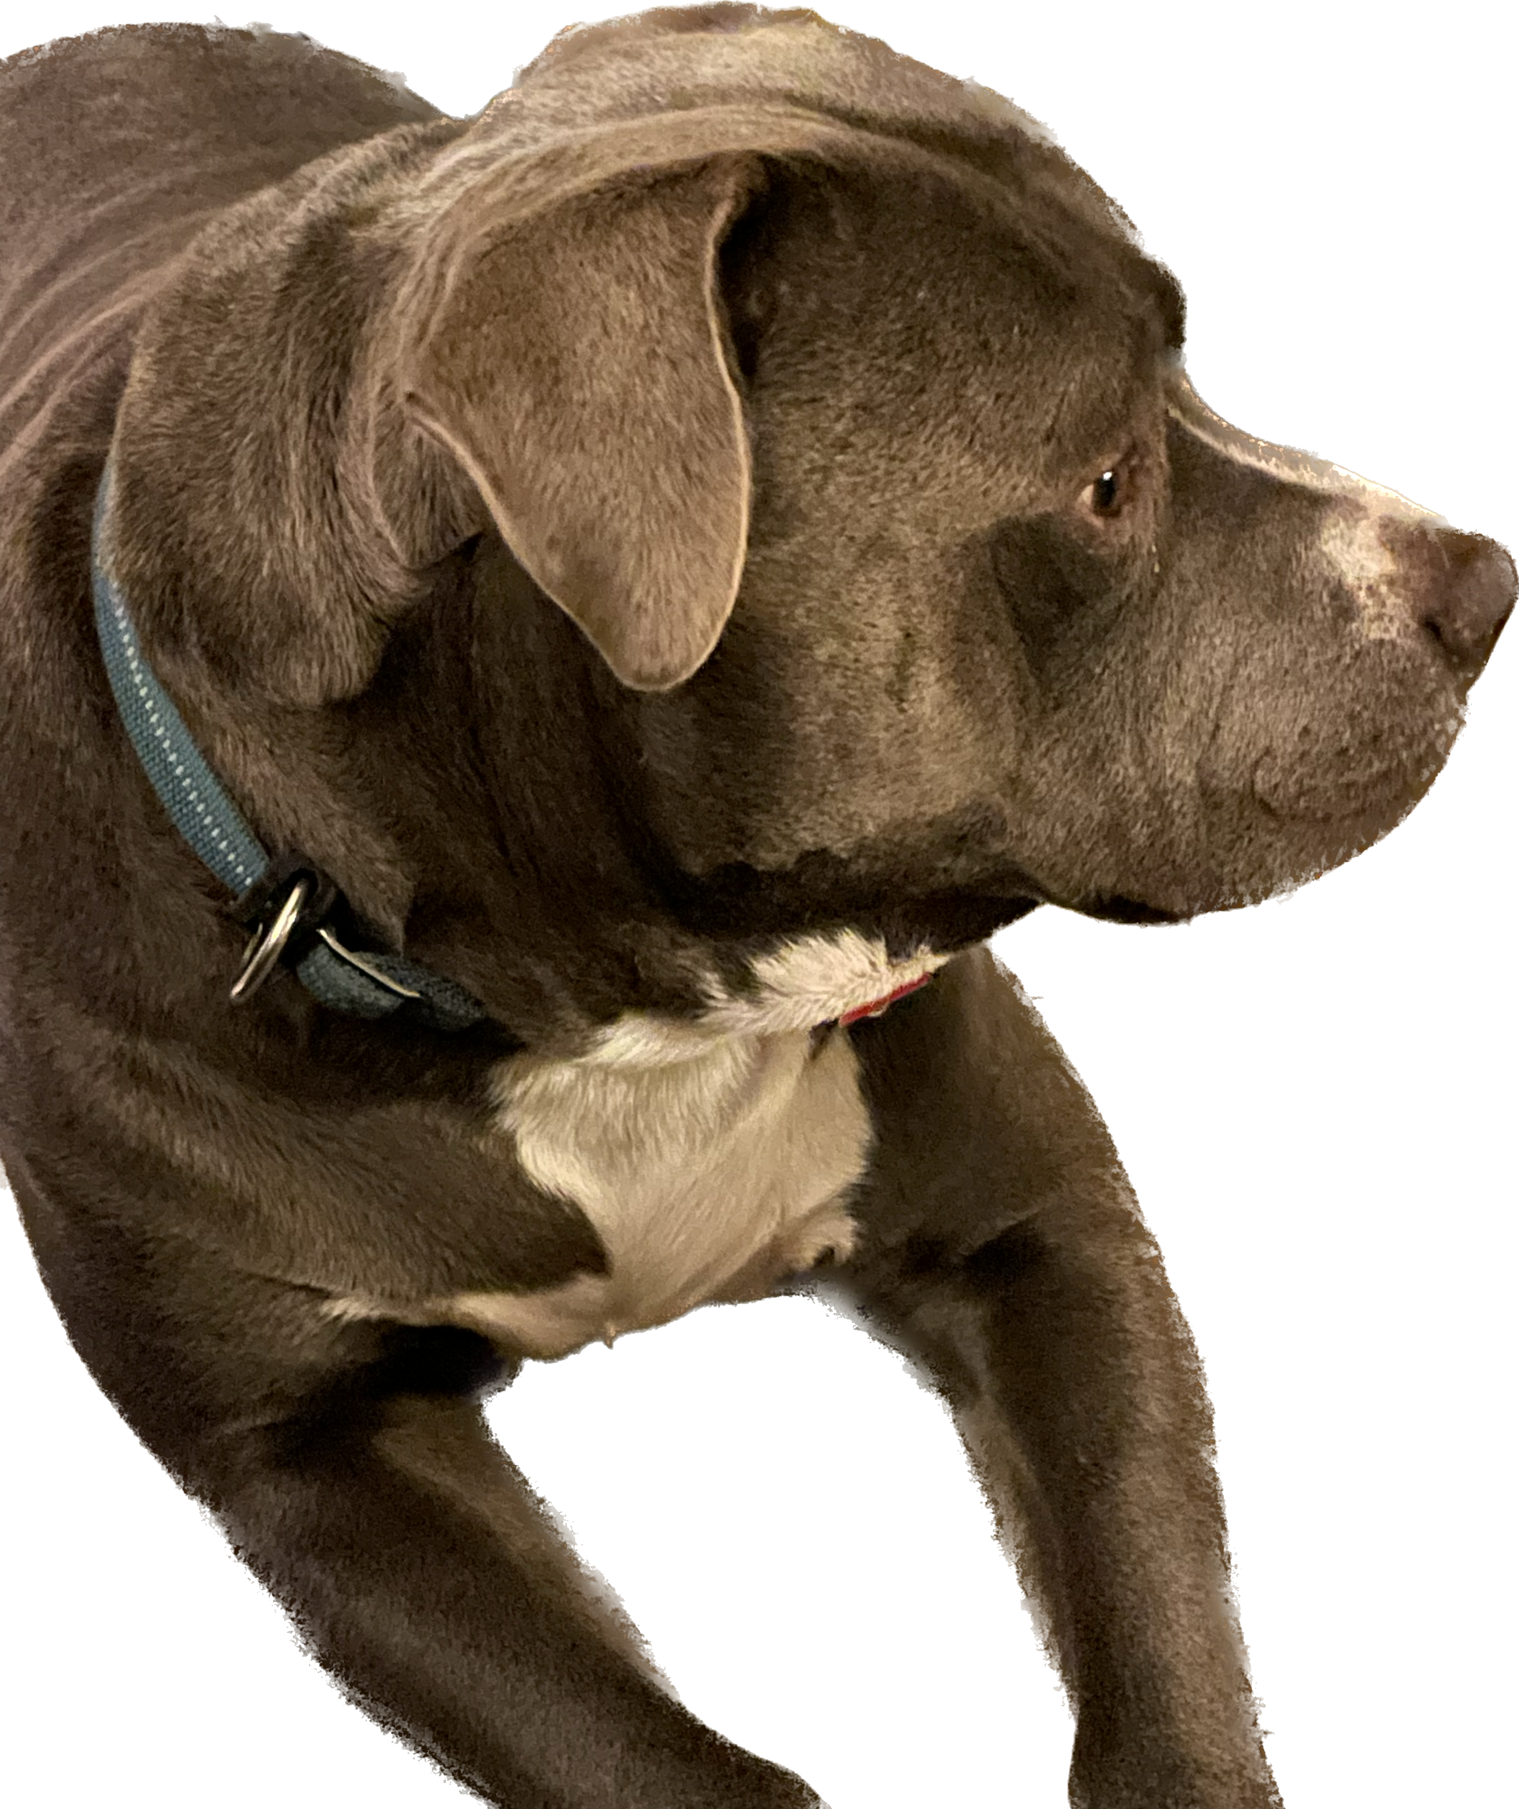
At The 49th Annual Georgia Blueberry Festival Stage

Judging: May 30, 2023 5:00 PM
Goldwasser Park in Alma, GA
Winners will receive a certificate, ribbon, and a gift basket. To print an application, go to www.georgiablueberryfestival.com

Circle One or More:
Biggest Dog Smallest Dog
Most Obedient Best Trick
Best Purebred Best Mutt
Prettiest Girl Most Handsome Boy Dog/Owner Lookalikes

Special Category: Dog the Judge would Most like to take Home
$10 Registration Fee to go to the purchase of a Dog waste Station for Goldwasser Park.

Cutoff May 20, 2023

To enter, please mail completed application, with shot record and payment to GA Blueberry Festival PO Box 213; Alma, GA 31510. Questions? Please email CJYBBF@GMAIL.COM
Rules of The 2023 Blueberry Puppy Dog Show
- All entries should be assured their dogs are free of internal and external parasites, any communicable diseases, and must have appropriate vaccinations including up-to-dates rabies vaccines. (ATTACH Copy of Up-To-Date Rabies Shot Record to Application)
- Entry fees are NOT refunded if a dog is absent, disqualified, sick, lame, excused by a judge, or barred from the show because it has been entered incorrectly.
- NO female dogs in heat are allowed in the dog show.
- Georgia Blueberry Festival and its members and volunteers may remove a dog from the show on account of disease, viciousness, or other causes and no one shall have any claim or recourse against Georgia Blueberry Festival or any member or volunteer thereof.
- NO entry fees are returned if the show cannot open or be completed by reason of civil disturbances, national emergencies, health emergencies, extreme weather conditions, fire, an Act of God, public emergency, and dictates of law enforcement or the City of Alma and its facilities or any other cause beyond the control of Georgia Blueberry Festival.
- Any handler under 12 years of age must be accompanied by an adult.
- Dog urine and waste must be cleaned up by their owners/handlers immediately.
- NO dog under 6 months is allowed to enter to the show.
- All Dogs MUST be always kept on a leash and under the control of its owner/handler.

I certify that the dog entered is NOT a hazard to persons or dogs. I further certify that I will abide by ALL Rules of The 2023 Blueberry Puppy Dog Show listed above.
I agree to hold harmless Georgia Blueberry Festival, all members individually, all volunteers and the city of Alma for damages at the show site.
Signature of Owner (must be 18 or older): _______________________________ Date: ___________________
Owner of Dog (Print): ________________________________________ Dog’s Name: ___________________
Handler (if under 12, name of accompanying adult): _______________________________________________
Email: ___________________________________________ Cell: ____________________________________
Name of Dog’s Vet: ______________________________ Dog’s Vet. Number__________________________
Tell us a little about your Pup:
Write in the Category: ____________________________________________________________________________________________________________________
Name: ______________________________________________________ Age: ________________________
Description________________________________________________________________________________
Breed (if known or what do you think): __________________________________________________________
Tell us something special about your Pup? _______________________________________________________
_________________________________________________________________________________________ __________________________________________________________________________________________

